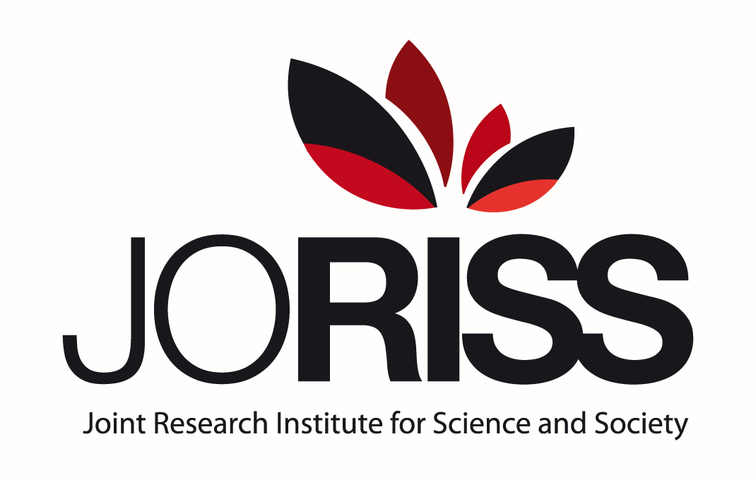

2020 CALL FOR RESEARCH PROJECTS

PRE-ANNOUNCEMENT

The 11th Call for Research Projects of the Joint Research Institute for Science & Society (JoRISS) will be officially released on September 1, 2020.

The deadline for submission will be November 2, 2020.

In the tradition of previous calls, two categories of projects will be eligible :
1/ projects dealing with a priority research domain
2/ free topic projects (« Projets blancs »).

New projects can receive up to 30 000 euros for an incubation period of 2 years.

This preliminary announcement is intended to provide potential applicants with a sufficient amount of time for establishing the necessary scientific contacts.

If you are interested in initiating or developing a scientific research collaboration between East China Normal University and University of Lyon through this 2020 JoRISS call, you are invited to discuss your project with one of the two JoRISS coordinators at your earliest convenience. They will assist you in your search for scientific partners as well as in formatting the project adequately.

- ECNU Coordinator: Professor ZHOU Yunxuan, zhouyx@sklec.ecnu.edu.cn
- ENS de Lyon Coordinator: Professor Jean-Michel Roy Jean-Michel.Roy@ens-lyon.fr

• General conditions of eligibility:
All research projects must be jointly headed by an East China Normal University (ECNU) affiliated investigator and an investigator affiliated with a member institution of the University of Lyon (UDL).
UDL teams including investigators from various members institutions of UDL are encouraged.
Complementary participation as team members of investigators from other institutions than ECNU and UDL is possible.

• Reminder : What is JoRISS ?

The Joint Research Institute for Science and Society (JoRISS) is an international and interdisciplinary research platform created in 2010 in order to foster scientific research collaborations between the East China Normal University of Shanghai (ECNU) and the the Ecole Normale Supérieure de Lyon (ENS de Lyon). In the context of the IDEX Program, it was fully opened to researchers of other insitutions of the University of Lyon in 2019.

